**Exp No 8 - Practice Queries using Aggregate functions, Group By, Having Clause and Order by Clause.**

**SELECT MIN(Price) FROM Products;**

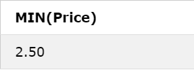

**SELECT MAX(Price) FROM Products;**

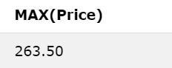

**SELECT AVG(Price) FROM Products;**

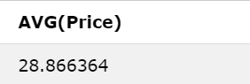

**SELECT COUNT(ProductID) FROM Products;**

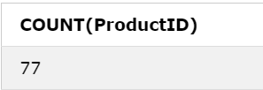

**SELECT SUM(Price) FROM Products;**

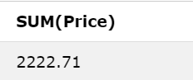

**SELECT COUNT(CustomerID), Country FROM Customers GROUP BY Country;**

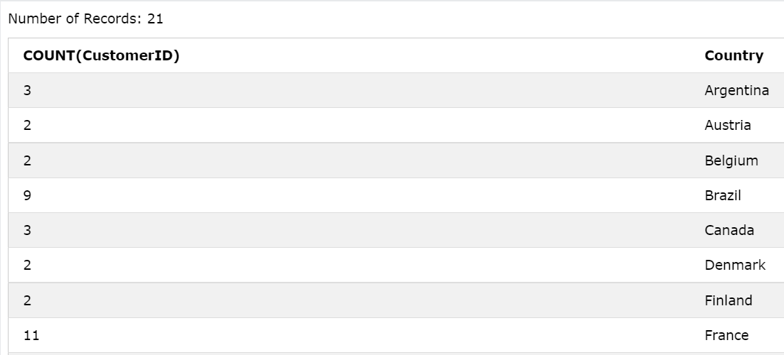

**SELECT COUNT(CustomerID), Country FROM Customers GROUP BY Country HAVING COUNT(CustomerID) > 5;**

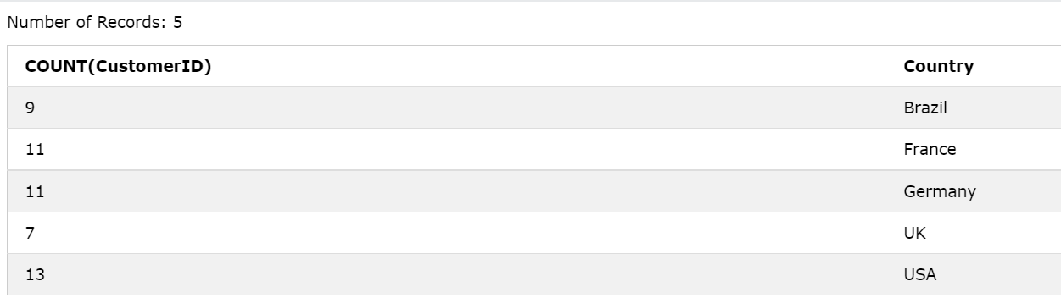

**SELECT * FROM Customers ORDER BY Country DESC;**

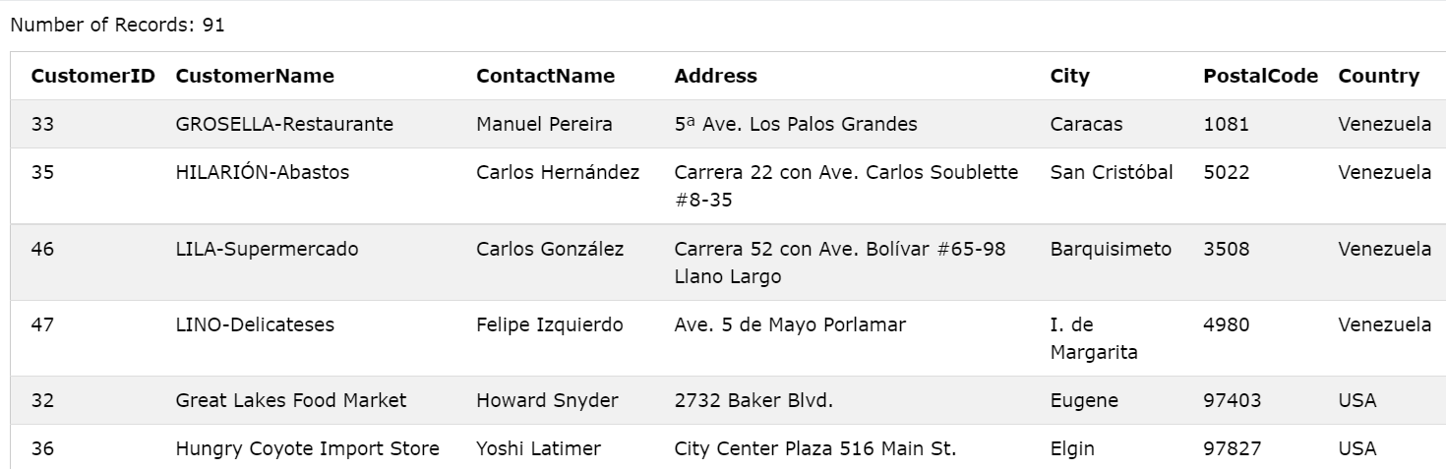

**SELECT * FROM Customers WHERE CustomerID = 1;**

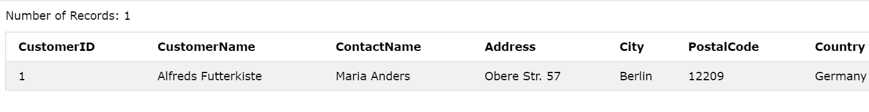

**SELECT * FROM Customers WHERE CustomerID <> 1;**

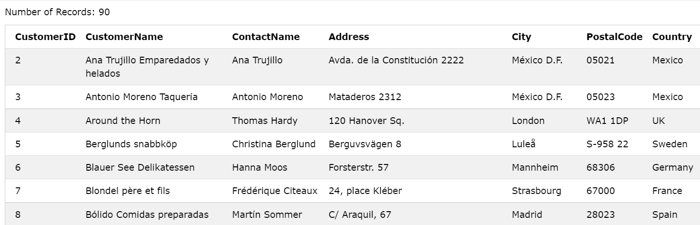

**SELECT * FROM Customers WHERE CustomerName LIKE 'a%';**

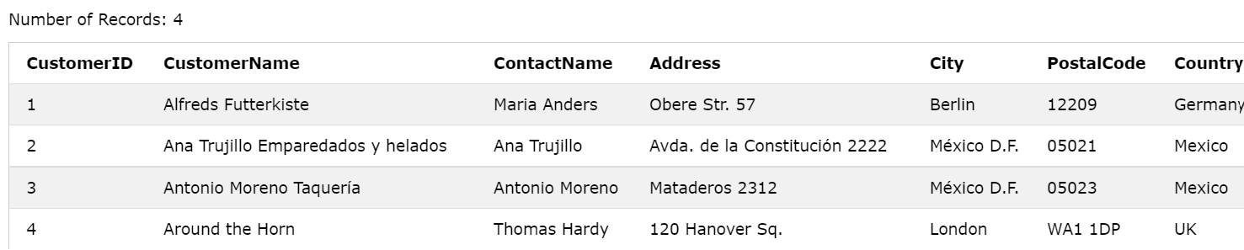

**SELECT * FROM Customers WHERE Country = 'Germany' AND City = 'Berlin';**

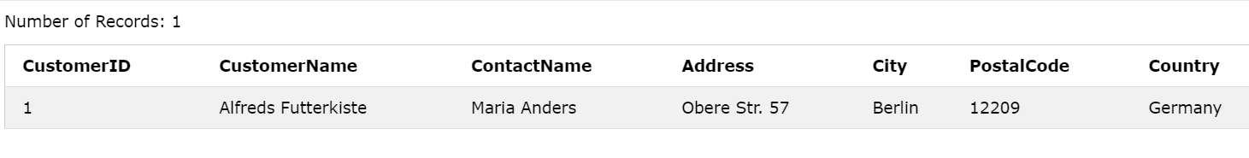

**SELECT * FROM Customers WHERE Country = 'Germany' OR City = 'Berlin';**

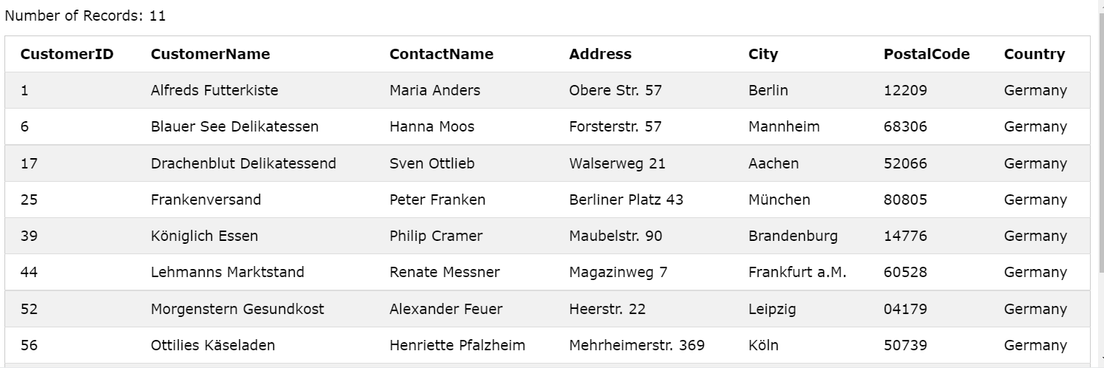

**SELECT * FROM Customers WHERE NOT Country = 'Germany';**

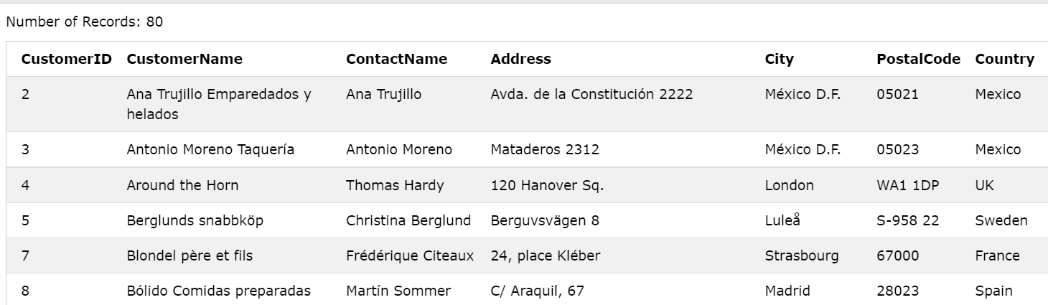

**CREATE VIEW [Brazil Customers] AS SELECT CustomerName, ContactName FROM Customers WHERE Country = 'Brazil';**

**SELECT * FROM [Brazil Customers];**

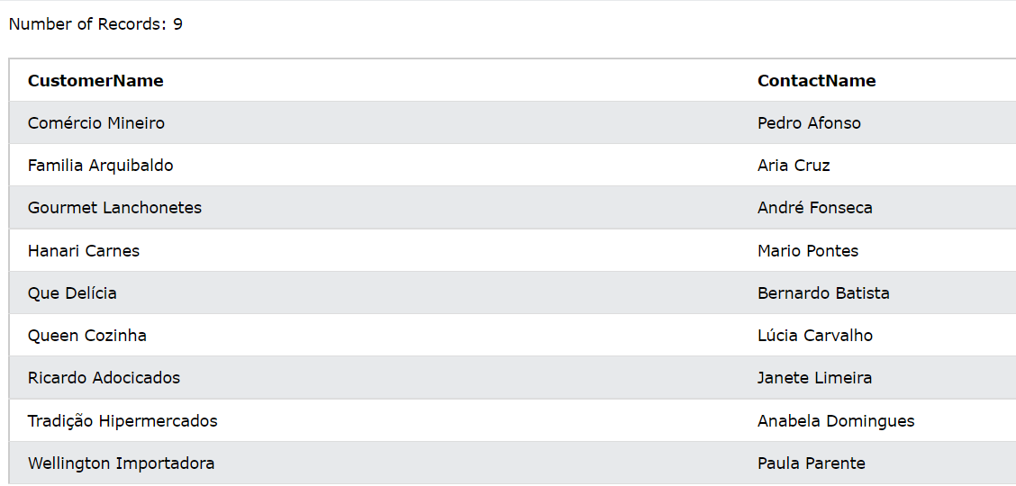

**DROP VIEW [Brazil Customers];**